Julia Karpeisky, CPCC, PCC

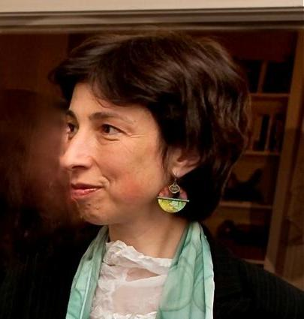

[juliamk@jmkcontact.com](mailto:juliamk@jmkcontact.com)

703-869-2058

**EDUCATION, CERTIFICATIONS & TRAINING**

|  |  |
| --- | --- |
| PCC | International Coach Federation |
| CPCC  Certified | Completed CTI (Coaches Training Institute) certification program, 2012  Hogan Personality Assessments, 2010 |
| Certified | Executive Coaching, Franklin Covey, 2001 |
| Certified | Conflict Management, CDR Associates, Boulder, CO, 1998 |
| M.A. | International Communications, Patterson School of Diplomacy and International Commerce, University of Kentucky, 1992 |
| M.S. | Molecular Biology, Moscow State University, Russia, 1987  *Julia Karpeisky holds US Government Top Secret Clearance* |

**COACHING and CONSULTING**

Julia has 10 years experience as a professional coach. She supports leaders as they maximize results and joy of their cross-cultural initiatives. She helps her clients bring out what’s truly alive in them, articulate and accomplish their goals, while maintaining a sense of meaning and healthy balance in their lives. She uses qualitative and quantitative assessments to identify changes her clients wish to make and supports them as they grow to achieve their goals.

***TESTIMONIAL:***

*“I'm confident enough with the process Julia follows, and the results that I've seen her help myself and others accomplish, to say that any firm that works with Julia will see a transformation in the executive team that she coaches. I recommend her work highly*. “ **Vicki Bogenberger, Senior Financial Executive, CH2MHill, Inc.**

As the result, clients get more clarity, make better decisions, which leads to more fulfillment, excitement and satisfaction with their lives inside and outside the workplace.

When asked, she shifts from coaching to consulting sharing her expertise in productivity and international communications.

Many of Julia’s clients are senior executives responsible for programs of $50MM and above.

**INTERPRETING**

Julia has 20+ years experience as a professional Russian interpreter. She facilitates communication at the highest levels of business and government, including for the **U.S. President,** Chairmen of ExxonMobil, Chevron Texaco, Conoco Phillips, President of the WorldBank, and the Brookings Institution.

**TRAINING**

Julia has over ten years experience in design and delivery of training programs in English and Russian languages.

***“Living an Inspired Life: Tools for Being Fully Engaged.”*** (© JMK Contact Inc., 2006-2012).

Executive Leadership Development Program. This renewal program strengthens connections between the team members, and allows them to align their personal goals with those of the organization. Program includes an all-day offsite, and follow-up individual coaching sessions.

***“There IS Enough Time: Advanced Productivity for Senior Executives*** (© JMK Contact Inc., 2007-2012). Executive Leadership Development Program. Program includes a ½ day offsite, a 2-hour follow-up team session, and follow-up individual coaching sessions.

***TESTIMONIAL***

*Julia is an engaging speaker, and a talented facilitator. I highly recommend her program for senior executives or anyone interested in improving their productivity.*

**Ray Tyler, Vice President**

**CH2M HILL Environmental Services Business Group**

***“Take it Personally: Achieve Lasting Results in International Relations***” (© JMK Contact, Inc. 2004-2012) A proven method for optimizing results and experience of projects where information is exchanged in more than one language. Designed for middle to senior level managers and executives, and originally delivered for George Washington University.

***Cross-Cultural Competencies for Lawyers*** Explains cultural bases of behavior and communication styles***.*** The program is approved for continuing legal education credits and was originally offered through West Legal Ed Center (www.westlegaledcenter.com).

**FACILITATION, NEGOTIATION** **AND CONFLICT MANAGEMENT**

* A series of meeting for the executive leadership team of **a Fortune 500 company focused on company reorganization.**
* Assisted a US biotech start-up in **closing a $1.8MM** deal with a Russian investor.
* A week-long **trilateral meeting to produce a five-year strategy** for the Arctic Military Cooperation Program (US Dpt of Defense) in English and Russian languages.
* Senior executive meeting for a biotech company which resulted in a decision to terminate the CEO. Successfully mediated the **CEO exit package negotiations**.
* **Lead parties out of a bypass** in a Russian-American Joint Venture negotiation, which allowed the client to avoid a $1MM+ write-off.

**EMPLOYMENT HISTORY**

**JMK CONTACT, INC**., ([www.jmkcontact.com](http://www.jmkcontact.com)) Founder and Principal, **1995 – present**

An international communications company helping clients succeed in their international endeavors. Clients include Exxon Mobil, Chevron, The World Bank, Intelsat, Harvard, Yale, Duke, George Washington and American Universities, The Library of Congress, US Government, Carnegie Endowment for International Peace, The Brookings Institution, and many others.